ASSIGNMENT NO.6
Data Manipulation and Table Management

Q1) Create MySQL database CollegeDB and tables Course and Student

CREATE DATABASE CollegeDB;

USE CollegeDB;

CREATE TABLE Course (
CourseID INT PRIMARY KEY,
CourseName VARCHAR(50) NOT NULL,
Fees DECIMAL(10,2) NOT NULL
);

CREATE TABLE Student (
StudentID INT PRIMARY KEY,
StudentName VARCHAR(50) NOT NULL,
Age INT,
City VARCHAR(30),
CourseID INT,
FOREIGN KEY (CourseID) REFERENCES Course(CourseID)
);
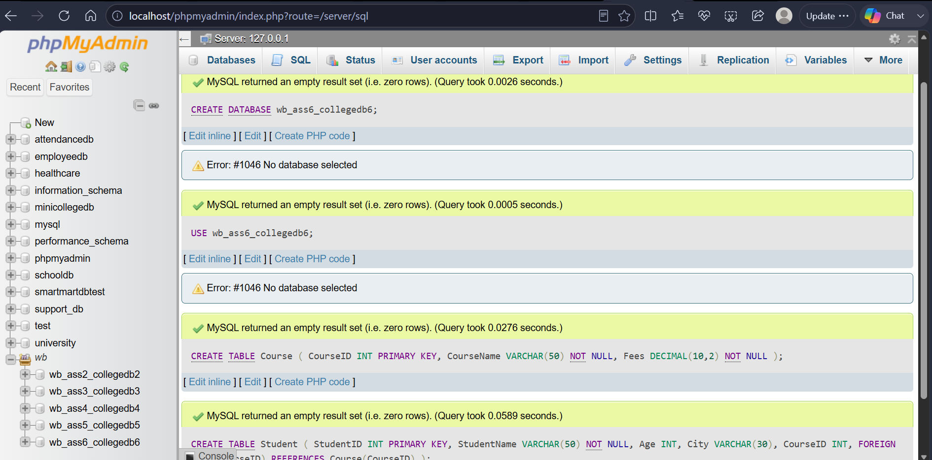

Q2) Insert at least 4 Course records and 6 Student records

INSERT INTO Course
(CourseID, CourseName, Fees)
VALUES
(101, 'BSc IT', 45000.00),
(102, 'BCA', 40000.00),
(103, 'BSc CS', 42000.00),
(104, 'Data Science', 55000.00);

INSERT INTO Student
(StudentID, StudentName, Age, City, CourseID)
VALUES
(1, 'Rahul Sharma', 20, 'Mumbai', 101),
(2, 'Priya Patil', 19, 'Pune', 102),
(3, 'Aman Verma', 21, 'Nashik', 103),
(4, 'Sneha Joshi', 20, 'Mumbai', 101),
(5, 'Karan Mehta', 22, 'Thane', 102),
(6, 'Neha Shah', 19, 'Pune', 104);

SELECT * FROM Course;
SELECT * FROM Student;

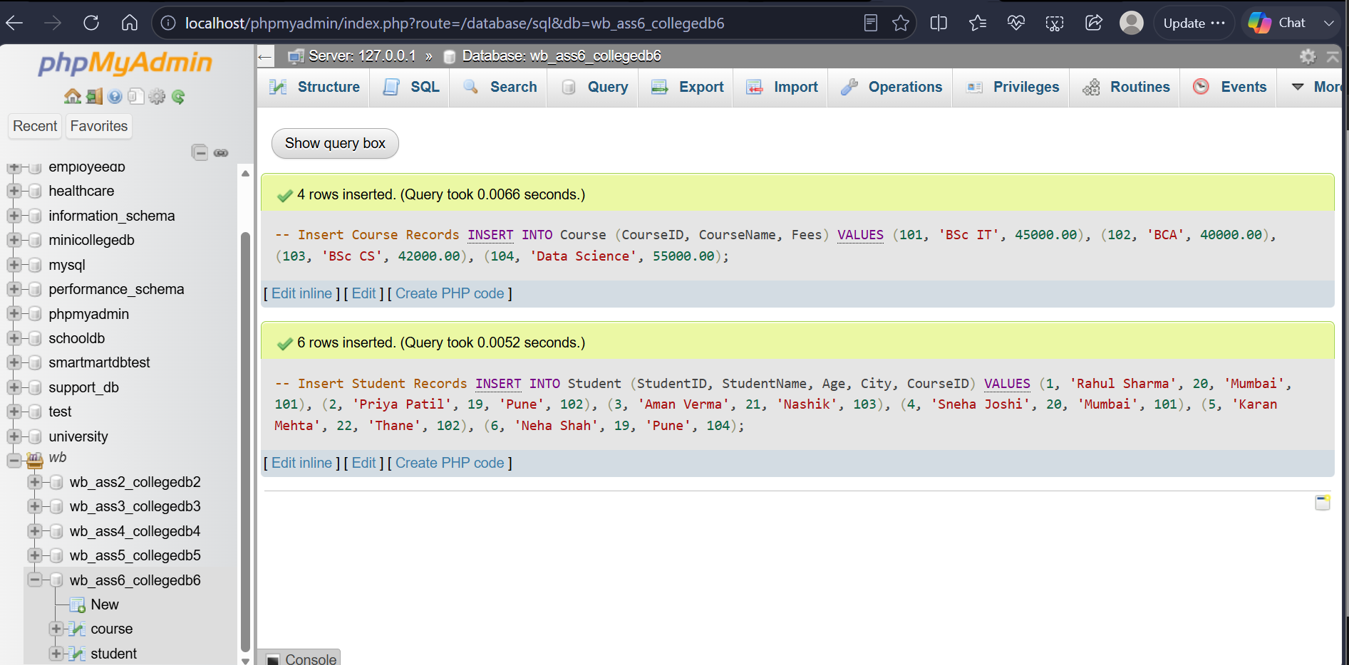

Q3) Insert one new student record

INSERT INTO Student
(StudentID, StudentName, Age, City, CourseID)
VALUES
(7, 'Rohan Desai', 21, 'Mumbai', 103);

SELECT * FROM Student
WHERE StudentID = 7;

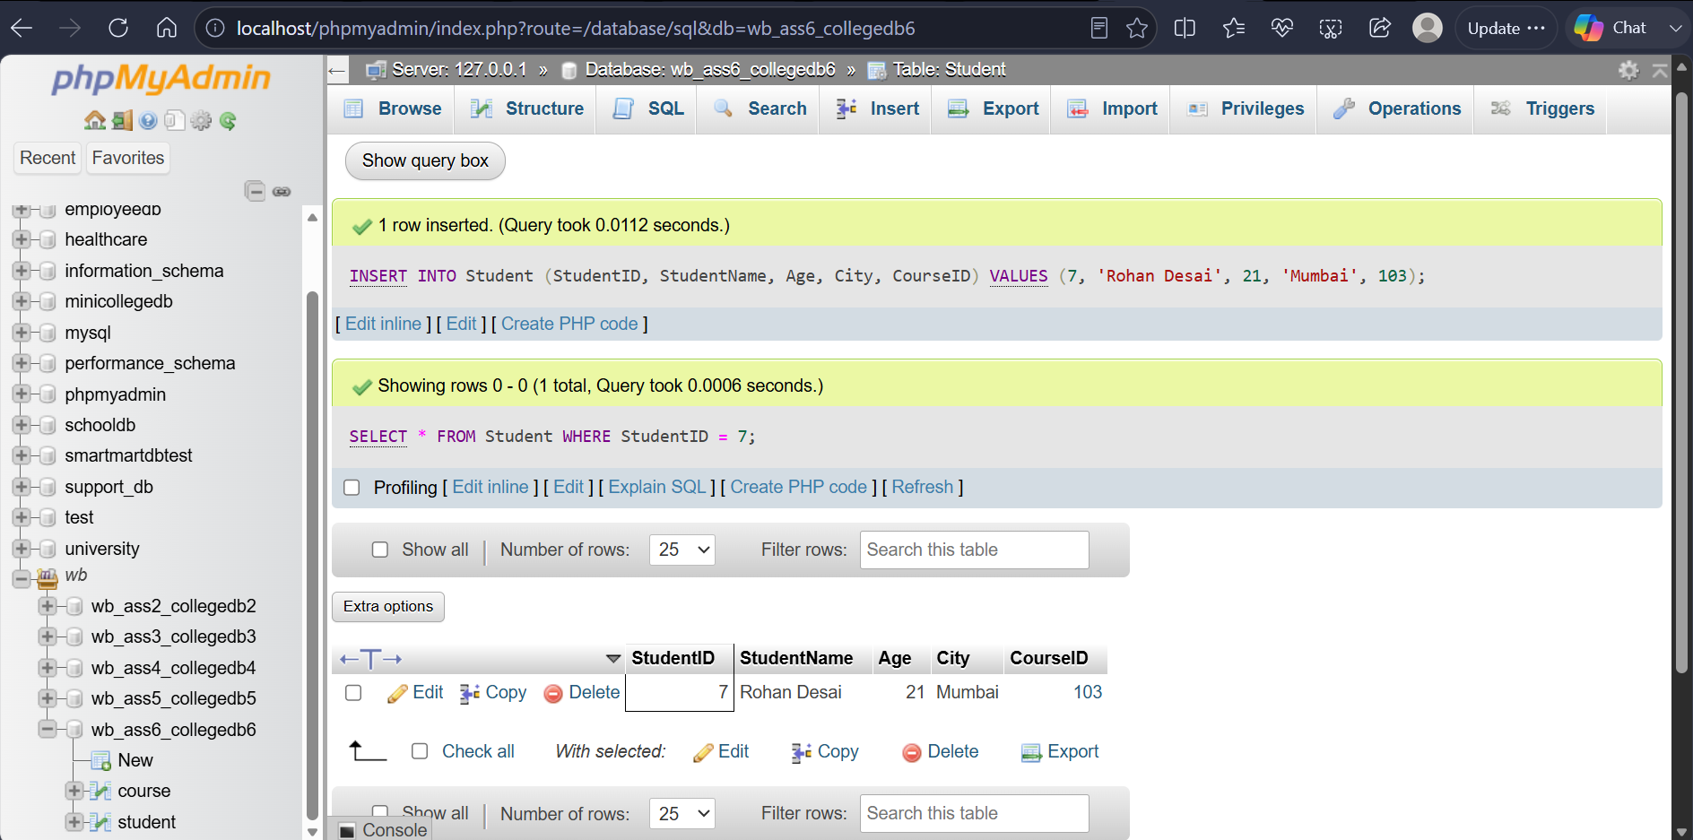

Q4) Update the city of StudentID 2 to Mumbai

UPDATE Student
SET City = 'Mumbai'
WHERE StudentID = 2;

SELECT * FROM Student
WHERE StudentID = 2;

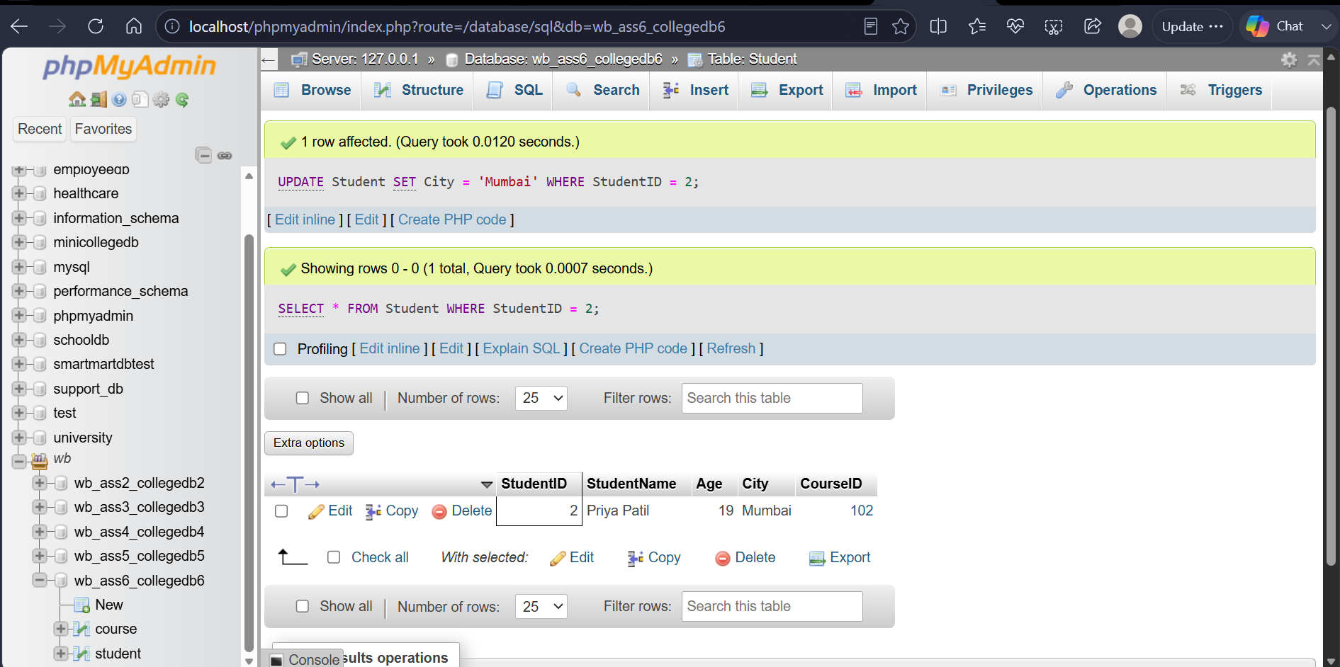

Q5) Update fees of CourseID 101 to 47000

UPDATE Course
SET Fees = 47000.00
WHERE CourseID = 101;

:
SELECT * FROM Course
WHERE CourseID = 101;

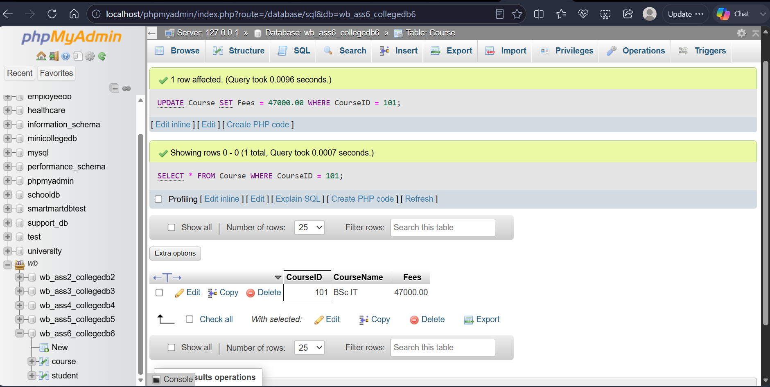

Q6) Delete one student record using StudentID

DELETE FROM Student
WHERE StudentID = 6;

SELECT * FROM Student;

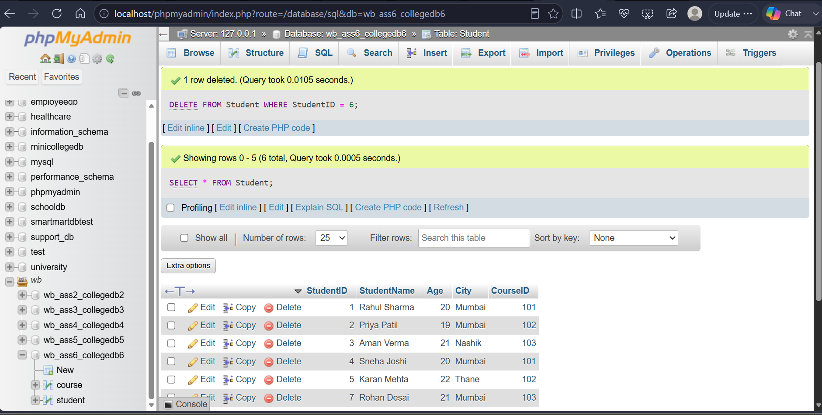

The WHERE clause ensures that only the specified student record is deleted.
Without WHERE, all records from the Student table would be deleted.

THANK YOU

